Windows Composer 安装

官网<https://getcomposer.org/download/> 下载

安装

1.

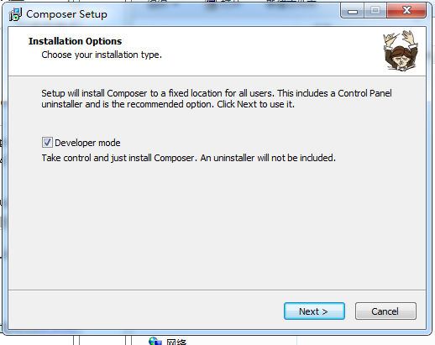

2.

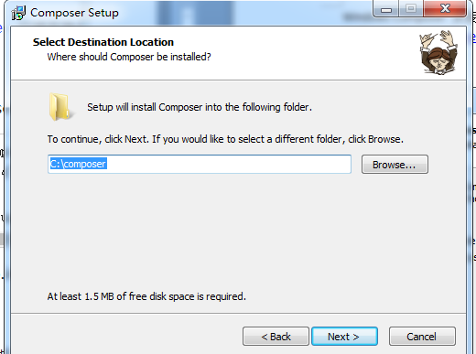

3.找到phpstudy下的版本php.exe,

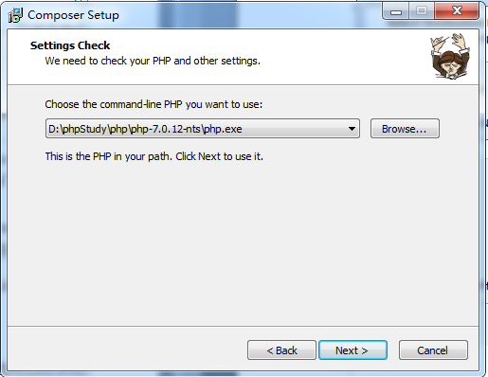

4.

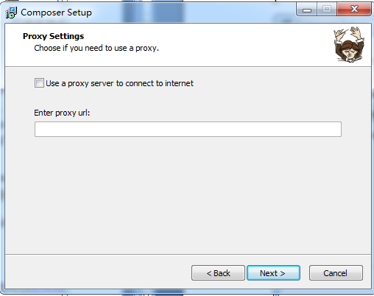

5.

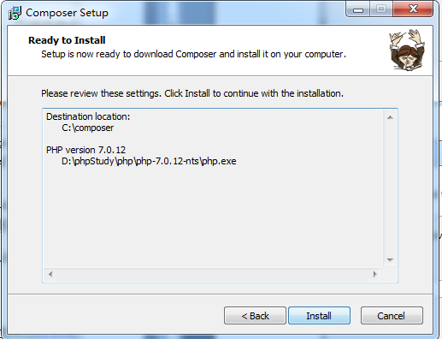

6.

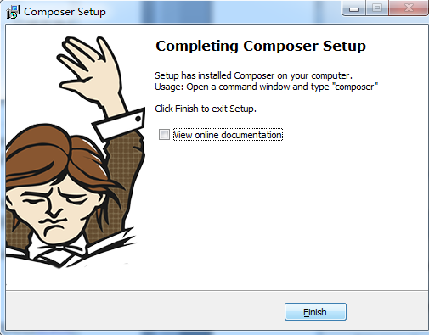

7.重启phpstudy 才生效

CMD 命令

检查是否安装成功 composer –v

出现以下则安装成功：

C:\Users\Administrator>composer -v

______

/ ____/___ ____ ___ ____ ____ ________ _____

/ / / __ \/ __ `__ \/ __ \/ __ \/ ___/ _ \/ ___/

/ /___/ /_/ / / / / / / /_/ / /_/ (__ ) __/ /

\____/\____/_/ /_/ /_/ .___/\____/____/\___/_/

/_/

Composer version 1.8.0 2018-12-03 10:31:16

Usage:

command [options] [arguments]

Options:

-h, --help Display this help message

-q, --quiet Do not output any message

-V, --version Display this application version

--ansi Force ANSI output

--no-ansi Disable ANSI output

-n, --no-interaction Do not ask any interactive question

--profile Display timing and memory usage information

--no-plugins Whether to disable plugins.

-d, --working-dir=WORKING-DIR If specified, use the given directory as workin

g directory.

-v|vv|vvv, --verbose Increase the verbosity of messages: 1 for norma

l output, 2 for more verbose output and 3 for debug

Available commands:

about Shows the short information about Composer.

archive Creates an archive of this composer package.

browse Opens the package's repository URL or homepage in your br

owser.

check-platform-reqs Check that platform requirements are satisfied.

clear-cache Clears composer's internal package cache.

clearcache Clears composer's internal package cache.

config Sets config options.

create-project Creates new project from a package into given directory.

depends Shows which packages cause the given package to be instal

led.

diagnose Diagnoses the system to identify common errors.

dump-autoload Dumps the autoloader.

dumpautoload Dumps the autoloader.

exec Executes a vendored binary/script.

global Allows running commands in the global composer dir ($COMP

OSER_HOME).

help Displays help for a command

home Opens the package's repository URL or homepage in your br

owser.

i Installs the project dependencies from the composer.lock

file if present, or falls back on the composer.json.

info Shows information about packages.

init Creates a basic composer.json file in current directory.

install Installs the project dependencies from the composer.lock

file if present, or falls back on the composer.json.

licenses Shows information about licenses of dependencies.

list Lists commands

outdated Shows a list of installed packages that have updates avai

lable, including their latest version.

prohibits Shows which packages prevent the given package from being

installed.

remove Removes a package from the require or require-dev.

require Adds required packages to your composer.json and installs

them.

run-script Runs the scripts defined in composer.json.

search Searches for packages.

self-update Updates composer.phar to the latest version.

selfupdate Updates composer.phar to the latest version.

show Shows information about packages.

status Shows a list of locally modified packages, for packages i

nstalled from source.

suggests Shows package suggestions.

u Upgrades your dependencies to the latest version accordin

g to composer.json, and updates the composer.lock file.

update Upgrades your dependencies to the latest version accordin

g to composer.json, and updates the composer.lock file.

upgrade Upgrades your dependencies to the latest version accordin

g to composer.json, and updates the composer.lock file.

validate Validates a composer.json and composer.lock.

why Shows which packages cause the given package to be instal

led.

why-not Shows which packages prevent the given package from being

installed.

//项目文件下的composer.josn 的内容

{

"name": "administrator/HouseCraftsman",

"authors": [

{

"name": "langyuanzhang",

"email": "982466450@qq.com"

}

],

"require": {

"phpoffice/phpspreadsheet": "^1.4",

"tecnickcom/tcpdf": "^6.2"

},

"repositories": {

"packagist": {

"type": "composer",

"url": "https://packagist.phpcomposer.com"

}

}

}

在项目文件下新建（或自动生成 composer.josn文件）

使用扩展下载网址

<https://packagist.org/>

使用如下

D:\phpStudy\WWW\HouseCraftsman>composer install

则会自动在项目根目录下创建vendor 文件并下载 “require” 下的扩展

或者直接使用命令下载

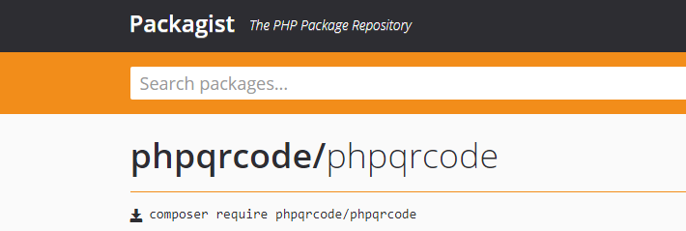

D:\phpStudy\WWW\HouseCraftsman> composer require phpqrcode/phpqrcode

可能需要配置环境变量

